FILMING / PHOTGRAPHY
REQUEST FORM
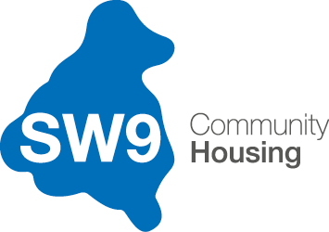

Please complete this form if you wish to film or carry out a photo shoot on the Stockwell Park Estate. Once received and agreed you will be provided with an Authorisation to Film/Photograph Notice by SW9 Community Housing.

Name

Organisation

Project Title

Description of the project

Areas the project will be filming/photographing (address, name of block, etc)
Date(s) and times filming will take place

Details of what resources will be on site during filming e.g. number of crew members, equipment, etc

Is there a risk assessment / health and safety guidance and insurance in place?

Has copies of the risk assessment / health and safety guidance and insurance been sent to SW9?

Is there any possibility that the project will bring SW9 or Stockwell Park into disrepute?

Do you agree to making a payment (hourly rate)?
Contact SW9 for rates
Name of responsible officer hiring and job title

Contact details for hirer include: email, mobile number

Date and Signature

Thank you for completing this form. This will now be reviewed for a decision. Please note that we may require further information and that no filming will take place until relevant payments have been made. For more information, please call 020 7326 3700.
All completed forms to be emailed to: getinvolved@sw9.org.uk

